**A PROGRESS REPORT ON**

**Oxidation Modelling of High Entropy Alloys (CoCrFeCuNi) at elevated temperatures using Stochastic Cellular Automata**

**Submitted by**

Aneesh Mukkamala, 822112

Teja Rao Koppala, 822106

Department of Metallurgical & Materials Engineering

NIT Andhra Pradesh

**Under the Supervision of**

Dr. R Sunil Kumar

Assistant Professor

Department of Metallurgical & Materials Engineering

NIT Andhra Pradesh



**May-2025**

**DEPARTMENT OF METALLURGICAL AND MATERIALS ENGINEERING**

**NATIONAL INSTITUTE OF TECHNOLOGY ANDHRA PRADESH**

TADEPALLIGUDEM-534101

**APPROVAL**

This project work entitled “**Oxidation Modelling of High Entropy Alloys (CoCrFeCuNi) at elevated temperatures using Stochastic Cellular Automata**” worked out by Aneesh Mukkamala (822112), Teja Rao (822106) is approved for the degree of Bachelor of Technology in Metallurgical and Materials Engineering.

**EXAMINERS**

**Dr Raffi Mohammed Dr R. Sunil Kumar**

**Assistant Professor Assistant Professor**

**Dept. of Metallurgical & Materials Engg. Dept. of Metallurgical & Materials Engg**.

**SUPERVISOR CHAIRMAN**

**Dr Sunil Kumar Dr. Raffi Mohammed**

**Assistant Professor Head of the Department**

**Dept. of Metallurgical & Materials Engg. Dept. of Metallurgical & Materials Engg.**

**Date: 02/05/2025**

**Place: Tadepalligudem**

**DECLARATION**

The following statement affirms that the written submission is an authentic representation of our own ideas, and that any external sources used have been properly cited and referenced. We acknowledge that we have adhered to principles of academic honesty and integrity, and have not misrepresented or falsified any data, facts, or sources. We understand that any breach of these principles may result in disciplinary action by the institution, as well as potential legal action from sources not properly cited or from which proper permission has not been obtained. It is essential to maintain academic integrity by giving proper credit to external sources and ensuring that all work submitted is our own. By adhering to these principles, we can promote trust, credibility, and professionalism in our academic work.

**Aneesh Mukkamala Teja Rao Koppala**

**822112 822106**

**CERTIFICATE**

It is certified that the work contained in the thesis titled “**Oxidation Modelling of High Entropy Alloys (CoCrFeCuNi) at elevated temperatures using Stochastic Cellular Automata**” by Aneesh Mukkamala bearing roll no. 822112 & Tej Rao Koppala bearing roll no. 822106 has been carried out under my supervision and this work has not been submitted elsewhere for a degree.

**Dr R Sunil Kumar**

**Metallurgical and Materials Engineering**

**National Institute of Technology Andhra Pradesh**

**May-2025**

**ACKNOWLEDGMENT**

To begin with, we would like to take this chance to express my utmost respect and appreciation to Dr R Sunil Kumar, our faculty advisor at MME, NIT Andhra Pradesh, for his unwavering support during our project work. His guidance and suggestions have been instrumental in helping us overcome the obstacles we encountered during our research. Working under his supervision has enabled us to excel in our chosen field.

We would like to express my gratitude to Dr. Raffi Mohammed, the Head of the MME Department, and Dr. Sunil Kumar for their encouragement and support. We would like to extend our heartfelt thanks to all our faculty members for supporting us throughout our academic journey**.**

**Aneesh Mukkamala 822112**

**Teja Rao Koppala 822106**

**ABSTRACT**

The oxidation behavior of high-entropy alloys (HEAs) plays a critical role in their high-temperature performance, particularly for applications in aerospace, nuclear, and energy systems. In this study, we present a physics-informed cellular automata (CA) model for simulating the oxidation kinetics of HEAs, explicitly incorporating temperature-dependent diffusion coefficients and activation energies of metal-specific oxides. Unlike prior approaches that approximate oxide growth using a dominant oxide (e.g., Cr₂O₃), our framework allows oxide-specific oxygen diffusion and competitive oxidation reactions based on thermodynamic stabilities and mobility of constituent oxides such as MnO, NiO, Fe₂O₃, and CuO. Elemental-specific oxidation probabilities and oxide reduction mechanisms are introduced to capture exchange reactions and oxide penetration dynamics under varying temperatures. The model was validated on CoCrFeCuNi alloy system across a range of temperatures, revealing realistic oxide growth rates, diffusion depths, and compositionally-driven oxidation patterns. This flexible CA framework lays the groundwork for predictive oxidation modeling in complex alloy systems and supports future integration with microstructural and stress-based phenomena. This set-up has rich features with compute efficient methods to be run without accelerated hardware. The modelling set-up is robust to be used with any allow system with any molecular distribution and at any temperature required. The final results mimic those observed from real-world experiments where real alloys are used and subjected to actual oxidation processes. The resulting data from the experiments can be used for spatio-temporal analysis and the findings can be exteded to analyse 3d changes in the alloy system utilising the 2d data. The main crux of the modellling uses 2d grids of 100x100 cells where each cell represent a metal cluster. Hence Von-Neuman neighbourhood criteria was used for the simulation. Unlike Moore neighbourhood criteria where for a given cell, all the 8 neighobours are used for comparison, here only 4 are used. Our experiment is currently developed to study the forestated chemical behaviours for 2d thin films of the alloys. Further information regarding, set-up, automata conditions and rules for iterations are discussed in more detail.

|  |  |  |  |  |
| --- | --- | --- | --- | --- |
| **S.no** | **Title** | | | **Page no.** |
| 1 | Introduction | | | 8 |
| 2 | Literature review | | | 9 |
|  | 2.1 Brief history Of High Entropy Alloys | | 9 |
|  | 2.2 Definition | | 10 |
|  | 2.3 Four core effects | | 10 |
|  |  | 2.3.1 High entropy effect | 11 |
|  |  | 2.3.2 Sluggish diffusion effect | 12 |
|  |  | 2.3.3 Lattice distortion effect | 13 |
|  |  | 2.3.4 Cocktail effect | 14 |
|  | 2.4 Classification | | 14 |
|  |  | 2.4.1 Entropy Alloys | 15 |
|  | 2.5 Processing Routes | | 18 |
| 3 | Idea and Set-up | | | 19 |
|  |  | 3.1 Research gaps | | 19 |
|  |  | 3.2 Current modelling setup aims at the following objectives | | 19 |
|  |  | 3.3 Experimental procedure | | 19 |
| 4 | Methodology | | | 21 |
|  | 4.1 Diffusion Coefficients, Probability Conversion & Activation Energies | | 21 |
|  | 4.2 Surface and Bulk reactions | | 22 |
|  |  | 4.2.1 Surface Oxidation | 22 |
|  |  | 4.2.2 Bulk Oxidation | 23 |
|  |  | 4.2.3 Surface, Bulk Reduction | 24 |
| 5 | Results and Discussions | | | 26 |
| 6 | Use cases in real world applications | | | 31 |
| 7 | Conclusion | |  | 32 |
| 8 | References | |  | 33 |

1.Introduction

High-entropy alloys (HEAs), comprising multiple principal elements in near equi atomic proportions, have emerged as promising materials for advanced engineering applications due to their exceptional mechanical properties, phase stability, and corrosion resistance. Oxidation, a surface degradation phenomenon caused by high-temperature exposure to oxygen, can dramatically influence the performance and lifetime of materials under thermal and mechanical stress. For HEAs, the oxidation behaviour is often complex, influenced not only by the elemental composition but also by competitive oxide formation, diffusion barriers, and environmental factors like temperature and oxygen partial pressure. Traditionally, oxidation studies and models have focused on dominant oxide formers, such as Cr₂O₃, due to its high thermodynamic stability and protective nature. Many previous computational models have hardcoded Cr₂O₃ as the primary oxide layer and treated oxygen diffusion uniformly through this barrier. While this simplification has yielded some success in binary and ternary alloy systems, it fails to capture the intricacies of multi-component HEAs, where several metal oxides—such as Fe₂O₃, CoO, CuO, and NiO—can simultaneously nucleate, grow, compete, or even replace each other dynamically during high-temperature exposure.

In this study, we develop a temperature-aware cellular automata (CA) model that captures the spatial and temporal evolution of oxidation in HEAs by integrating oxide-specific behaviour. The model calculates oxygen diffusion based on a modified Arrhenius-type temperature dependence, using individual diffusion coefficients and activation energies specific to each metal oxide. Additionally, the simulation considers competitive oxidation-reduction dynamics, where less stable oxides may be replaced by more stable ones if adjacent to a reactive metal species. These dynamics are modelled in a two-dimensional grid, where oxidation, oxide diffusion, and reduction are evaluated in a stepwise fashion, simulating realistic growth of oxide layers over time.

We investigate a single representative HEA **CoCrFeCuNi**. The CA model simulates how oxygen penetrates the metal surface, how different metal atoms oxidize based on their local environment and thermodynamic tendencies, and how oxide layers evolve and migrate over thousands of time steps. Importantly, this approach allows us to visualize and quantify oxide formation in a physically grounded yet computationally efficient manner.

By shifting from a hardcoded, oxide-agnostic model to a temperature-dependent, oxide-specific simulation, this work provides a robust platform for predicting oxidation kinetics in HEAs. The model offers insights into how alloying elements and operating conditions shape oxidation resistance, and it sets the stage for future enhancements such as microstructure coupling, stress interactions, and multi-scale simulation integration. The oxidation and diffusion speed are controlled solely by hyperparameters and thus reducing the overall number of iterations being performed on the cell. There is usage of probability random sampling during the modelling to incorporate variance in the progress and to avoid deterministic outputs. Due to this the progression of the oxidation matches the results as of real-world scenarios. Our methodology includes tailor made formulas, equations and hyperparameters which have carefully chosen after rigorous testing across multiple conditions

1. Literature Review

The potential research towards the development of High Entropy alloys, briefly discussed in introduction. In this chapter, a thorough and critical review of the existing literature in the field of development of high entropy alloys presented. The review is distributed into several sections, which are devoted to high entropy alloys based on 3D transition elements, their oxidation behaviour at higher temperature and the effect of active element addition on the oxidation kinetics.

### **2.1 Brief history Of High Entropy Alloys**

The term “high entropy alloys” was initially introduced by Cantor and colleagues in 1981. They identified an alloy composed of iron, chromium, manganese, nickel, and cobalt in equal atomic proportions that formed a single-phase face-centered cubic (FCC) solid solution. In the 1990s, Yeh and his team delved deeper into the concept of multi-component alloys [20]. However, it's noteworthy that groundwork for this idea dates as far back as the late 18th century, when Franz Karl Achard, a German scientist and metallurgist, undertook early explorations [22]. His findings were published in French, primarily in tabular form without discussion, which led to the work being overlooked for over a century until Professor Cyril Stanley Smith revisited it in 1963.

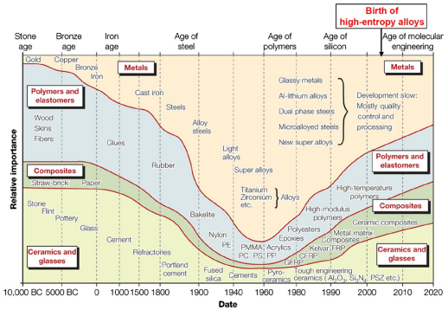

Fig 2.1 Historic Evolution of Materials from Stone Age to the Industrial Revolution Age [22].

The unique ability of high entropy alloys to form single solid solution phases with excellent properties—such as wear resistance, high hardness, thermal softening resistance, and superior corrosion and oxidation resistance—has drawn considerable global research attention [3–8].

### **2.2 Definition**

High entropy alloys were originally defined as metallic systems consisting of five or more principal elements in equiatomic ratios [1]. These alloys tend to form simple solid solution phases—face-centered cubic (FCC), body-centered cubic (BCC), or hexagonal close-packed (HCP)—due to their high configurational entropy [2–9].

More recently, the definition has evolved to include alloys in which each principal element is present in concentrations between 5 and 35 atomic percent, provided the system still forms a single-phase solid solution [7, 11]. However, enforcing a single-phase structure restricts the compositional space, and studies have shown that not all single-phase HEAs exhibit exceptional properties. While many researchers aim to design HEAs that form single-phase structures, recent modifications to the definition have relaxed this constraint. Indeed, multi-phase HEAs like Fe50Mn30Co10Cr10, TaxHfZrTi (where x ranges from 0.4 to 1), Fe20Co20Ni41Al19, and NbTiV2Zr have demonstrated superior performance compared to some equiatomic single-phase systems [15–16]. In this work, we adopt the HEA concept as defined by Yeh et al. in 1995—a novel class of alloys containing at least five principal elements, each within the 5% to 35% atomic range [3,4]

Depending on the chosen compositions, HEAs typically form simple solid solution phases such as FCC or BCC. Thermodynamically, a system strives to attain a stable or metastable equilibrium by minimizing its Gibbs free energy (ΔGmix). The enthalpy of mixing (ΔHmix) and configurational entropy (.ΔSmix) contribute to the Gibbs free energy at a given temperature (T), expressed in Kelvin, as shown in Equation 1.

### **2.3 Four core effects**

In general, the equiatomic or near-equiatomic nature of high entropy alloys gives rise to several unique effects that are typically not prominent in conventional alloys. This section provides a concise overview and discussion of the four fundamental effects of HEAs, as summarized by J.W. Yeh [22]. These include the high-entropy effect, sluggish diffusion effect, lattice distortion effect, and the cocktail effect.

**2.3.1. High Entropy Effect**

The high-entropy effect, originally introduced by J.W. Yeh, suggests that an increased entropy value lowers the Gibbs free energy of solid solution phases, thereby favoring their formation over intermetallic compounds, which possess lower configurational entropy [3–11, 22]. As outlined in Equation 1, a solid solution phase can be stabilized by enhancing the mixing entropy. In HEAs, this high entropy characteristic is primarily a result of the deliberate composition design using equimolar ratios.

To evaluate the solidification behavior of an alloy system, it is necessary to compute the Gibbs free energy difference between the solid and liquid phases (ΔG) under undercooled conditions. However, accurately calculating ΔG becomes increasingly complex in multi-element systems. To address this challenge, Takeuchi and Inoue [22] proposed a hypothesis:

G at a certain composition is proportional to the mixing free energy of ΔGmix of the liquid phase, which is determined from the following equation:

.………(1)

where T is the absolute temperature, Hmix the mixing enthalpy and SmixThe mixing enthalpy for a multi-elements system with n elements is expressed as equation 4 [22]

.………(2)

where ΔHmix ij AB H 

is the regular solution interaction parameter between the ith and jth elements, ci or cj is the atomic percentage of the i th and jth component, and ΔHAB mix the mixing enthalpy of binary liquid alloys.According to Boltzmann’s hypothesis, the mixing entropy of an n-element regular solution is shown below [22]:

.………(3)

.………(4)

The mixing entropy of an equimolar alloy system is generally at its maximum. For example, as illustrated in the schematic diagram of ΔSmix for a model ternary alloy system (Fig. 2-1), compositions nearer to the central region exhibit higher ΔSmix values [6]. Additionally, solid solution phases possess greater mixing entropy compared to intermetallic compounds [22]. Consequently, it is more likely that solid solutions, rather than intermetallics, become the stable phases in high-entropy alloys. Furthermore, the overall degree of order in HEAs tends to decrease with rising temperature. As a result, even ordered phases present in as-cast alloys may transform into disordered solid solution phases at elevated temperatures.

**Table 2.1** Configurational entropies in terms of R with constituent elements up to 13 for equiatomic alloys [22].

|  |  |  |  |  |  |  |  |  |  |  |  |  |  |
| --- | --- | --- | --- | --- | --- | --- | --- | --- | --- | --- | --- | --- | --- |
| **n** | **1** | **2** | **3** | **4** | **5** | **6** | **7** | **8** | **9** | **10** | **11** | **12** | **13** |
| **∆**Smix/ R | **0** | **0.69** | **1.1** | **1.39** | **1.61** | **1.79** | **1.95** | **2.08** | **2.2** | **2.3** | **2.4** | **2.49** | **2.57** |

However, it has been observed that the findings of Senkov et al. suggest single solid solution phases in HEAs become less likely as the number of constituent elements increases—contradicting the high-entropy effect, which posits that greater configurational entropy should stabilize disordered solid solution phases in HEAs [24]. According to Senkov et al., while the configurational entropy does increase with the addition of more elements, it does so gradually, whereas the likelihood of intermetallic compound formation rises more rapidly [15–16].

**2.3.2. Sluggish diffusion effect**

Studies on various high-entropy alloys have shown that their diffusion rates and phase transformation kinetics are slower compared to those of conventional alloys [3, 5, 20, 22]. According to J.W. Yeh et al., this sluggish diffusion effect arises from the variations in local atomic energies. These variations are caused by differing local atomic configurations, which in turn lead to diverse bonding environments and thus different energy states at each atomic site.

On one hand, in conventional alloys, the local atomic configuration remains nearly unchanged when an atom moves into a lower-energy site. In contrast, in HEAs with high solute concentrations, atoms are more likely to become “trapped” due to the complex local environments. On the other hand, if an atom jumps into a high-energy site, it is highly probable that it will return to its original position [22]. Both of these scenarios contribute to the reduced diffusion rates observed in HEAs. Furthermore, phase transformations typically require the coordinated movement of multiple elements; therefore, the presence of slowly diffusing elements hinders such transformations in HEAs.

To date, the sluggish diffusion effect has been used to explain the precipitation of nano-sized intermetallic phases in HEAs, where the nucleation of intermetallic compounds occurs readily but their growth proceeds slowly [1]. Additionally, this effect contributes to the high-temperature strength and exceptional creep resistance of HEAs [22]. However, the underlying mechanisms of slow diffusion kinetics in HEAs remain insufficiently explored. Recently, Tsai et al. demonstrated that atomic diffusion coefficients in the CoCrFeMnNi alloy are lower than those in ternary alloys and pure metals. Correspondingly, the activation energies in HEAs are higher than in conventional counterparts [31]. Using a quasi-chemical model, they also analysed fluctuations in lattice potential energy across various matrices. According to Tsai et al., greater fluctuations in lattice potential energy create more pronounced traps and barriers for atomic movement, leading to increased activation energies and, consequently, explaining the sluggish diffusion effect in HEAs [31].

**2.3.3. Lattice distortion effect**

Compared to alloys with a single principal element, HEAs often exhibit a pronounced lattice distortion effect, particularly in BCC-dominated high entropy alloys. In conventional alloys, lattice sites are typically occupied by one or two major elements. In contrast, in HEAs, atoms of varying sizes occupy these sites, inevitably leading to lattice distortion and associated lattice strains (see Fig. 2-2). Numerous studies have shown that this severe lattice distortion hinders dislocation motion, resulting in significant solid solution strengthening [3, 20, 22]. Although HEAs with a simple FCC structure generally show lower strength and hardness [22], they still outperform conventional single-FCC phase alloys in terms of strength, largely due to the influence of lattice distortion. However, there is currently no research that quantitatively assesses lattice distortion in HEAs or clearly establishes the relationship between the extent of distortion and the mechanical strength of these alloys.

In addition to solid solution strengthening, the severely distorted lattice in HEAs also contributes to the scattering of electrons and phonons, which results in increased electrical resistivity and decreased thermal conductivity [3, 22]. To investigate the significant reduction in XRD intensities observed in HEAs, Yeh et al. conducted a quantitative analysis of the X-ray diffraction peak intensities for a series of HEAs (CuNiAlCoCrFeSi) [27]. Yeh's study attributes the changes in XRD intensities to a combination of thermal effects and lattice distortion effects. Furthermore, the lattice distortion effect is also linked to the tensile brittleness and slower kinetic processes in HEAs [5].

**2.3.4. Cocktail effect**

The term ‘cocktail’ effect is firstly used by S. Ranganathan [20] for alloys with concentrated compositions, including bulk metallic glasses, super-elastic and super-plastic metals and HEAs. It now means a composite effect coming from the basic features and interactions among all the elements, in addition to the indirect effects of the various elements on the microstructure or properties [11]. The effect is usually used to explain the rather remarkable or unexpected properties of multi component alloy [7]. However, different from the other three core effects proposed as a theoretical hypothesis, the “cocktail effect” is too abstract and cannot be regarded as a hypothesis. Generally, the unknowns of the cocktail effect is related to the interplay between individual atomic species, which if lattice site occupancy is unknown, cannot be predicted. Currently, the meaning and influence of the cocktail effect is also a matter for debate since it is difficult to determine precisely what is meant by it and what makes it particularly special [3, 22].

### **2.4 Classification**

They hypothesized that the presence of multiple (five or more) elements in near- equiatomic proportions would increase the configurational entropy of mixing by an amount sufficient to overcome the enthalpies of compound formation, thereby deterring the formation of potentially harmful intermetallics[20, 22].

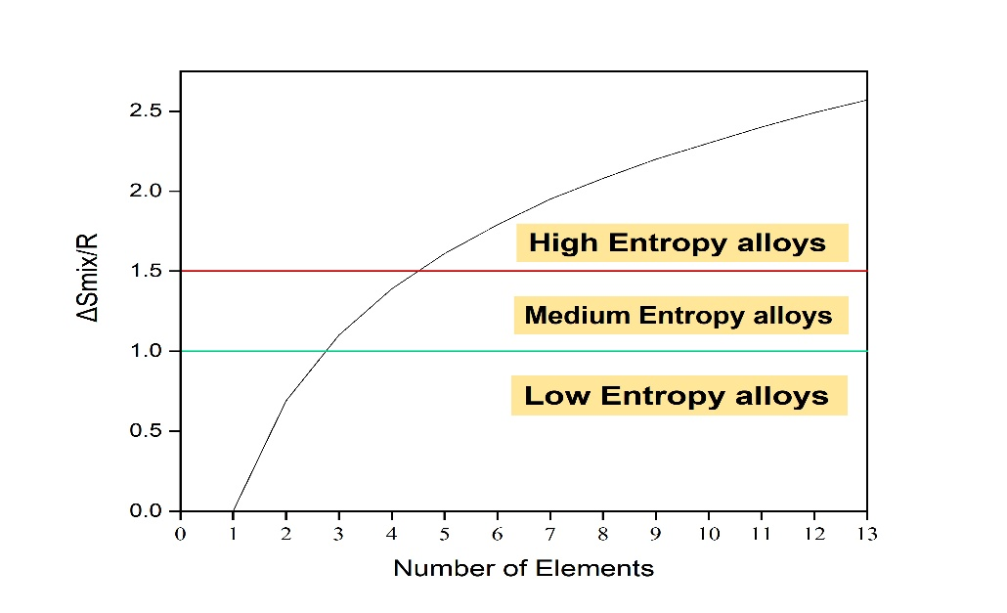

Fig. 2.2 Classification of entropy alloys.

This idea was counterintuitive, as the conventional perspective—likely derived from binary phase diagrams where solid solutions are usually found at the ends and compounds near the center—suggested that increasing the number of elements in concentrated alloys would increase the likelihood of some elements reacting to form compounds. However, Yeh and his colleagues argued that as the number of elements in an alloy grew, the entropic contribution to the total free energy would surpass the enthalpic contribution, thereby stabilizing solid solutions.

**2.4.1 Entropy Alloys**

The alloy system can be classified into low-entropy alloys (LEAs), medium-entropy alloys (MEAs), and high-entropy alloys (HEAs) based on the configurational entropy at the random solution state. HEAs are defined as alloys with a mixing entropy greater than 1.5R, where R represents the gas constant. In contrast, medium-entropy alloys (MEAs) have mixing entropy values between 1R and 1.5R, and low-entropy alloys (LEAs) have values below 1R.

Through a series of experiments, it was found that LEAs (such as Ni and CoNi), MEAs (such as CoFeNi and CoCrFeNi), and HEAs (such as CoCrFeMnNi) with a single FCC structure exhibited serration phenomena only in MEAs and HEAs. This provided the first quantitative explanation for the observed serration behavior, with its dependence on temperature, strain rate, and the composition of LEAs, MEAs, and HEAs.

The configurational entropies of these alloys at a random state range between 1R and 1.5R, indicating that they should be classified as medium-entropy alloys (MEAs). Despite having reduced configurational entropy, these MEAs possess outstanding microstructures and properties that can be compared to, or even surpass, those of HEAs. This finding not only redirected our focus toward MEAs but also inspired the development of a general approach for designing non-equiatomic MEAs. In this work, we propose a novel design for non-equiatomic MEAs that include one matrix element and several equiatomic alloying elements. To verify this design, we developed a series of Co-free Feₓ(CrNiAl)₁₀₀₋ₓ (at.%, x = 25, 35, 45, 55, and 65) MEAs, derived from the extensively studied FeNiCrCoAl HEA. Subsequently, we systematically examined the microstructures of these alloys and discussed their phase separation behaviors.

[High-entropy alloys](https://encyclopedia.pub/entry/10643) (HEAs) are defined as alloys composed of five or more principal elements with the molar ratio of each principal element between 5% and 35%. As one of the new materials that developed in recent years, HEAs have received more and more attention due to their unique property differences from traditional alloys for which the composition is based on one or two principal elements. HEAs are mainly manifested as the following four core effects: high configuration [entropy](https://encyclopedia.pub/entry/18759) in thermodynamics, sluggish atomic diffusion in kinetics, severe lattice distortion effect in structure, and “cocktail” effect in performance. Due to their unique high-entropy effect, HEAs are easy to form a simple solid solution structure rather than intermetallic compounds, thus exhibiting high strength, high hardness, good ductility, and excellent thermal stability.

Since no standardized classification of HEAs exists, the classification below is based on their composition characteristics, phase, and element constituents, as illustrated in Fig. 2-3. In terms of composition, HEAs can be divided into equiatomic and non-equiatomic alloys. The number of elements in these alloys typically ranges from 4 to 6. Notably, the record for the most components in an equiatomic multicomponent alloy—20 elements—was set by Cantor and Alain Vincent [4]. Initially, research focused primarily on equiatomic HEAs, while in recent years, non-equiatomic HEAs have attracted increasing interest due to their broader compositional range and superior properties.

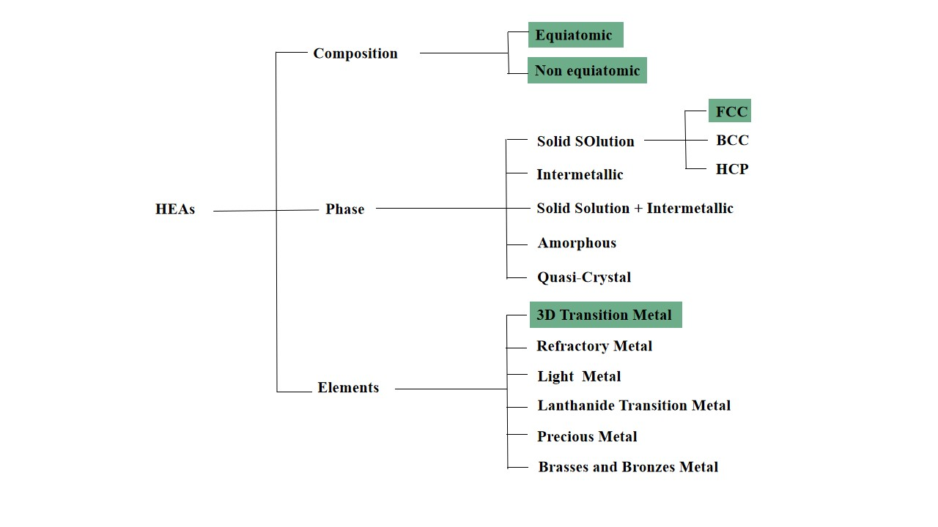

Fig. 2.3 Classification of High entropy alloys.

For classification based on phase constituents, HEA families are similar to traditional alloys and can be divided into solid solutions (SS), intermetallics (IM), SS + IM, amorphous, and quasi-crystal alloys. Among these, researchers seem particularly focused on developing HEAs with single-phase solid solutions or solid solutions with minor intermetallic phases. Specifically, the single-phase solid-solution (SS) structures typically exhibit face-centered cubic (FCC), body-centered cubic (BCC), or hexagonal close-packed (HCP) crystal structures [5-10].

Additionally, based on the type of elements, HEAs can be classified into six alloy families: 3d transition metal HEAs, refractory metal HEAs, light metal HEAs, lanthanide transition metal HEAs, HEA brasses and bronzes, and precious metal HEAs [7]. Among these, 3d transition metal HEAs are the most widely studied. They contain at least four of the following nine elements: Cr, Co, Fe, Ni, Mn, Cu, Al, Ti, and V, and can be seen as extensions of stainless steels and superalloys [7]. The equiatomic CoCrFeMnNi Cantor alloy is the most typical example. Beyond the 3d transition metal HEAs, refractory HEAs consist of more than four refractory elements, each with a melting point above 1650°C (e.g., Hf, Mo, Nb, Ta, V, and W), and generally display significantly higher strength at elevated temperatures compared to Ni-based superalloys [7].

The other alloy families are seldom reported due to various drawbacks, such as high cost, brittleness, and limited availability in bulk form, with further details available in Ref. [7]. Additionally, interstitial compound HEAs, which have a high content of B, C, or N, are not typically included due to their ceramic-phase constituents (e.g., nitrides, carbides, and borides), and are more commonly studied as high entropy ceramics. Transition metals are most frequently used in the synthesis of HEAs. The atomic radii of elements like Fe, Ni, Cr, Co, and Cu are quite similar, and the mixing enthalpies between them are mildly negative. As a result, HEAs composed of these elements tend to form simple FCC solid solutions, as reported by Chen et al.

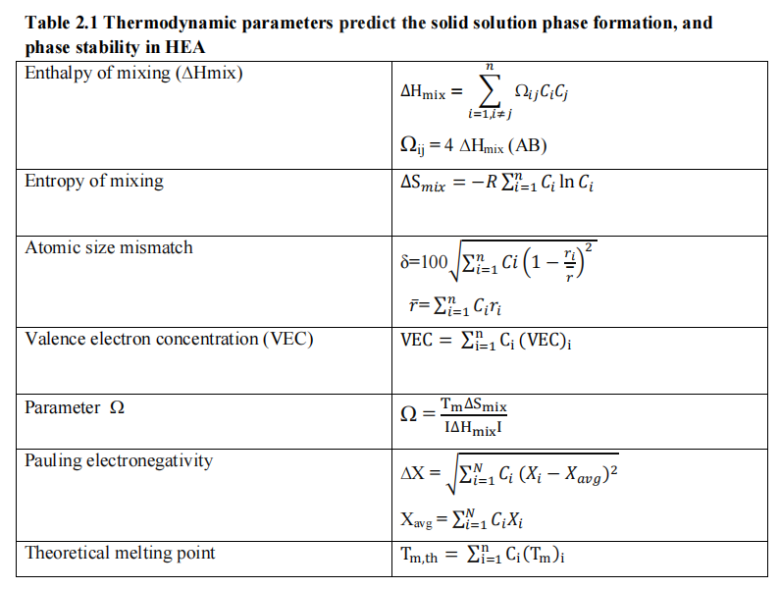

**Table 2.2** Thermodynamic Parameters to predict the solid solution Phase formation and Phase stability in HEA.

### **2.5 Processing Routes**

High entropy alloys can be fabricated using various routes, similar to conventional alloys, in forms ranging from ingots or slabs to powders, and from bulk materials to thin films. The processing route significantly influences the microstructure of the resulting high entropy alloy. However, the two most commonly used methods for preparing high entropy alloys are vacuum-arc melting and powder metallurgy [22].

Praveen and colleagues [17] prepared CoCrCuFeNi high entropy alloy through the powder metallurgy route, reporting the formation of two face-centered cubic (FCC) phases and a small amount of sigma (σ) phase. Tong and his team [27] synthesized the same alloy using the casting method, observing that the alloy consisted of a single face-centered cubic phase.

Ji and co-workers explored the phase evolution of AlCoCrFeNi alloy via mechanical alloying (MA) followed by spark plasma sintering (SPS) [28], finding a combination of face-centered cubic and body-centered cubic (BCC) phases after sintering. In contrast, when the same alloy composition was synthesized through arc melting by Wang and colleagues [29], only a single body-centered cubic phase was observed.

Thus, it can be inferred that the phase formation of a specific high entropy alloy is strongly influenced by the processing route, and this effect warrants further investigation. Furthermore, different processing routes can lead to various phase transformations in high entropy alloys composed of multi-component elements. Ultimately, processing routes play a crucial role in affecting phase evolution in high entropy alloys in a significant manner.

1. Idea and Set-up

### **3.1 Research gaps**

1) A limited literature is available on the high temperature oxidation behaviour of high entropy alloys.

2) Remedies for oxide scale spallation on the surface of high entropy alloys (Mn and Cu oxides) were not well addressed in the literature.

3) There are very few publications focused on predicting properties of HEAs.

### **3.2 Current modelling set-up aims at the following objectives**

1) To provide a unified stochastic based modelling approach aimed at studying oxidation

behaviours of any high entropy metal alloy

2) To study behaviour of alloys at varying temperatures and holding time in thin film alloy

materials without any additives

3) To develop spatio-temporal data of oxide layer formation across metal cross section for future research

### **3.3 Experimental procedure**

The main motive behind this project is to make a unified method to simulate oxidation of alloys at any temperatures. This would speed-up research areas in many fields of metallurgy. But to display a working prototype of our idea, we choose to apply this on a 5 -metal system / HEA on temperatures of 600, 700, 800, 900, 1000 Celsius similar what was done in   
We chose a 110x100 grid where the first 10 rows represent “air” or “oxygen”. The actual simulation occurs on the other 100x100 part of the grid. In all these 100,000 cells of the grid, based on the molecular distribution provided by the user, the metals are split accordingly and their placement in the grid is purely random. For our experiment we choose equimolar distribution (each 20%). Following this we made some assumptions and set the following conditions before the simulations even start.

Oxidation and metal degradation is only due oxygen reaction. Contribution of factors like pH, impurities are not taken into account. Metal defects are assumed to be absent as they might speed up oxygen diffusion through the metal lattices. Here oxygen diffusion for a single metal type is uniform across all it’s cells in the grid. The diffusion is based on the reaction rate oxygen diffusion from “air”. For this we took the values and equations “Fick’s laws of diffusion”. As we are assuming the diffusion based on Fick’s law, we only assume oxygen diffuses into metal via “air” or from the already formed oxide regions in the grid as the simulation progresses. This is one of the 3 main rules in the grid update equations as the simulation progresses.

Metal-Metal diffusion is not considered while it is fairly relevant in such alloy systems with low electronegativity difference between the metals in the alloys. Since activation energy and the diffusion coefficients are set before the experiment starts, pressure differences are assumed to be minimal and are neglected therefore. The oxidation rate is governed primarily by surface availability and local stability, rather than bulk diffusion or internal oxidation fronts. Once formed, oxides are assumed to remain on the grid unless reduced by a more stable oxide-forming metal. Effects such as oxide layer cracking, spallation, or evaporation (e.g., MoO₃ volatilization) are not modelled. The grid-based model does not currently simulate grain boundaries, phase segregation, or crystallographic orientation, all of which can influence oxidation paths. Each cell is treated as a homogeneous elemental unit.

1. Methodology

### **4.1 Diffusion coefficients, Activation energies, Probability conversion**

We referred many web scraping tools and multiple research papers to gather the values of “D0” for the diffusion coefficient for oxygen to pass through/ diffuse throughout an oxide cell/oxide layer. The values we collected are tabulated below. Similarly, we gathered the activation energies for the corresponding reactions.

The interpretation of values tabulated in Table 4.1) is as follows for an example: “O_through_Cr” corresponds to diffusion coefficient for oxygen diffusing through chromium oxide. 2.0e-17 = 2x 10^-17. 180e3 = 180x 10^3

|  |  |  |
| --- | --- | --- |
| Type of Diffusion | Diffusion Coefficient | Activation energy |
| O_through_Cr | 2.0e-17 | 180e3 |
| O_through_Fe | 2.8e-15 | 130e3 |
| O_through_Co | 5.0e-15 | 150e3 |
| O_through_Ni | 6.0e-15 | 160e3 |
| O_through_Cu | 4.0e-15 | 120e3 |

Table 4.1) Values for diffusion coefficients and activation energies for oxygen diffusion through metal oxide layers

The main idea is that as the D_adjusted increases, the diffusion is quicker indicating faster and rapid oxidation. We recommend setting temp_factor between 0.6-0.8

If temp_factor = 1: normal Arrhenius behaviour

If temp_factor > 1: steeper change, more sensitive to temperature

If temp_factor < 1: flatter response, less sensitive to temperature

The diffusion coefficients have to be converted to probability values. This is because the grid update uses the probability values of oxidation of any metal occurring to carry the reactions of the complete alloy system forward.

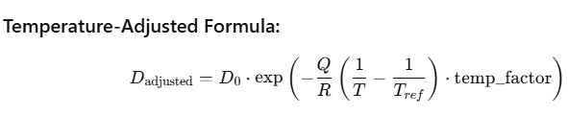

Probability Scaling for oxide diffusion -> Diffusion coefficient x 1e7

For O2-to-metal oxide diffusion, the resulting probabilities for each “O_through_metaloxide” should lie in the range of 0.011 to 0.003. Overall cumulative probability should not be greater than 1. So, in cases where priorities are given for specific metal oxides, the scale factor can be varied depending on metal used. Increasing the probability scale would mean that the oxide layers considered are thicker and diffusion is slower. Though we did not take into consideration of the metal-metal diffusion, if they are being considered the following strikes a good balance between speed and accuracy

Probability Scaling for Metal diffusion -> Diffusion coefficient x 1e2

Further we have noticed that sometimes the probability value of a single alloy may spike based on its behaviour relative to other elements. So we used min clipping to ensure the individual probability will not cross 0.05

🡪New_Prob = min(Old_Prob , clip_value)

### **4.2 Surface and Bulk reactions**

In our entire simulation, the changes and updates being made to the grid follow 3 main steps.

**4.2.1 Surface oxidation:**

This occurs to the very first row in the 100x100 grid which acts an entry point of the oxygen from the air. Following the oxide formation on the first row of the grid, the diffusion of oxygen is only considered to pass through the so-formed cells which get converted from metal-metal oxide. Hence in the first iteration only few cells of the first row get oxidised, and after around 1000 iterations occur, the complete oxidation of the surface layer occurs. The first 1-5 rows of the grid are in analogy to mimic surface layers of the alloys. For both systems, the metals are arranged in order of their stability with respect to the oxide formed.

🡪 CoCrFeCuNi Stability order: "Cr": 5, "Fe": 4,"Cu": 3,"Co": 2,"Ni": 1

This rule is to be followed for any metal system incorporated even if it is a 2-metal alloy system. After ranking the stability orders, the stability value assigned should be normalized to avoid inconsistent calculations in the upcoming equations.  
🡪 New stability = Old stability / number of metals in the alloy And we introduce two new parameter called “temp_effect” which control the impact of the temperature being used. Setting “temp_effect” is preferred to be between 0.2-0.5. This ensures the probability value obtained is not too small in the following equation below.

🡪 New temperature = (Old temperature/ reference temperature) ** temp_ effect

Following this we calculate the surface_oxidation_prob parameter for a particular grid cell as oxidation_prob = base_probability * New_stability * New_temperature  
Then we perform random sampling using NumPy to pick a decimal between 0-1 and if the oxidation_prob is greater than this number, the current grid cell gets updated to its corresponding oxide. The arg base_prob sets up the overall probability to be not too small and all these additional scaling and normalizing modifiers are a way to make the probability sampling as information dependent as possible.

Here reference temperature is assumed to be 1000 Celsius. And the 5 represents the number of alloys with base probability and temp_effect as 0.15 and 0.3 respectively



**4.2.2 Bulk oxidation:**

The earlier stated equations perform surface oxidation. This section deals with how the formed oxide cells in the first layer propagate the oxygen for further cells. The below states conditions only are applicable in the case where below an oxide cell there is a metal cell. The oxidation diffusion probability is similar to the earlier equation with slight changes.

🡪Probability = minimum ( D_prob * temp_modifier, 0.12)

🡪Temp_modifier here as follows 🡪 (Temperature/ 600) ** 0.5

Here D_prob is for diffusion of oxygen from the current oxide cell. These are calculated using the modified Fick’s law equation from earlier. It is suggested not to change the parameters 600 and 0.5. These were calculated s weights using Linear regression while we measured the offset between the results, we got from our simulation versus the actual data from oxidation at 700-900 Celsius for a range of alloy systems. The overall probability is capped at 0.12 (12%) to avoid unrealistic rates of oxidation. Following this random sampling is done to update the cell if the sampled value falls lesser than the probability. These conditions and reactions for bulk oxidation start to occur much more frequently after around 3000-5000 iterations. The main functionality differences are as below depicted in Table 4.2)

|  |  |  |
| --- | --- | --- |
| **Feature** | **Surface Layers**  **(Row 1)** | **Bulk Layers**  **(Rows 2)** |
| Region in Grid | Row 1 (just below air) | Anywhere below existing oxide layer |
| Trigger Condition | Direct Oxygen layer  contact | Oxygen-Oxide Diffusion based |
| Probability Calculation | Stability-based with base prob 0.15 | Diffusion-based probability coefficients |
| Temperature Influence | (T / T_ref ) ** 0.3 | (T/600) **0.5 |
| Cap on Probability | None | min (prob, 0.12) |

Table 4.2) Comparison of oxidation triggers, probability calculations and temperature rules between surface and bulk rows/layers of the grid. These contribute to two completely different oxidation algorithms based on bulk of material

**4.2.3 Bulk reduction:**

The previous reactions dealt with oxidation and Von-Neuman conditions were not actually used. Now that the oxides are formed, we assumed the possibility of reverse reaction of the oxidation (reduction). In this case, the neighbourhood elements in the top, bottom, left, right directions are compared to current cell. For boundary conditions, the missing direction is not considered for calculations and assumed to be as a vacuum condition. The stability order defined earlier now checks the current oxide cell’s stability relative the surrounding cells. If any of the 4 or 3 (boundary) cells have a more stable. This condition of reduction is relevant for both surface layer as well as bulk layers as once the oxide cells start forming, no matter their position in the grid, their stability and existence solely depends on that of their neighbouring metal cells. Although the oxide cell of one metal would be influenced by other metal oxide cells along with the metal cell, we did not take that information into consideration.

Scenario Example:  
🡪Current Grid cell = Cu Oxide  
🡪 Stability order = "Cr": 5, "Fe": 4,"Cu": 3,"Co": 2,"Ni": 1  
🡪Neighbours and directions  
 ↑ neighbour = 1 → Cr (metal)  
 ← neighbour = 4 → Fe (metal)  
 → neighbour = 0 → AIR  
 ↓ neighbour = 2 → Ni (metal)

Here from the neighbours, we can see that Cr and Fe are more stable compared to Cu. Hence the current grid cell gets reduced to Cu (from copper oxide) and the Iron and Chromium cells gets oxidized to their respective oxides. Similar random sampling followed by probability comparison is done to update the grid cells using the following formula. The choice of hyperparameters here are only constraint to the current alloy system this project deals with.

🡪Stability_difference = Stability_most_stable_neighbour - Stability_current_cell

🡪Temp_effect = exp(temperature – 600 / 300 )

🡪 Reduction Probability = 0.015 * Stability_difference * Temp_effect

Temperature Effect scaling is done to incorporate Arrhenius type equations.

If the sampled probability (0 to 1) is less than the Reduction Probability, the update occurs. These conditions run in competitive nature along with bulk oxidation starting at around 5000 iterations.

In scenarios where there might be more than 1 stable neighbour with respect to the current cell, priority of oxidation of neighbour cell is given in the following order

🡪 Up 🡪 Left 🡪Right🡪Down

1. Results and discussions

Following the experiment, we gathered around 100,000+ high quality files across the stated alloy systems at 600,700,800,900,1000 Celsius which represent snapshots of the grids at various iterations.

The dataset is publicly hosted on Kaggle at kaggle.com/aneeshmukkamala/modelling

Images present in Figure 5.1) to 5.3) represent how the grid progresses during across the simulation’s iterations. The grid snapshots have been saved at every iteration in all experiments. Below one can see only the snapshots at iteration – 0, 5000, 15000, 20000 respectively.   
The upper image shows state of the grid after 15000 iterations. It displays the metal-wise oxide presence in the grid. Each greyscale image presents how the locations of individual metal oxides across the grid. Rows 0 to 20 correspond to oxygen layer from the air. The black spots represent the metal oxide distribution. While the image seems like it is full of oxygen as the they share the same colour as of Rows 0 to 20, it is only done for illustrative purpose. The bottom image shows progression of grid. Although all the images of grid seem indistinguishable to human eye between close temperatures, they hold valuable information.

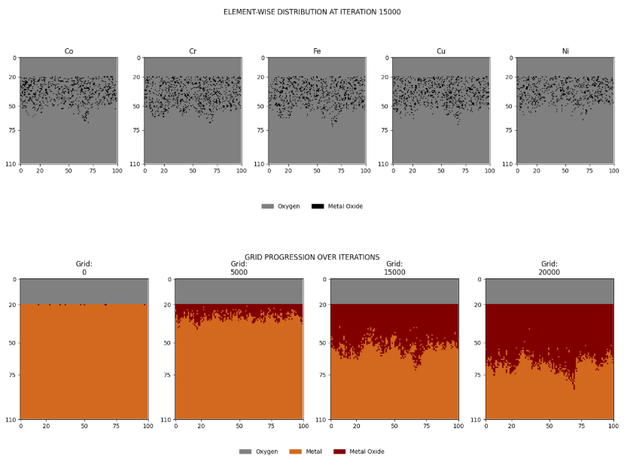  
 Figure 5.1) Grid progression for CoCrFeCuNi alloy system at 1000 Celsius



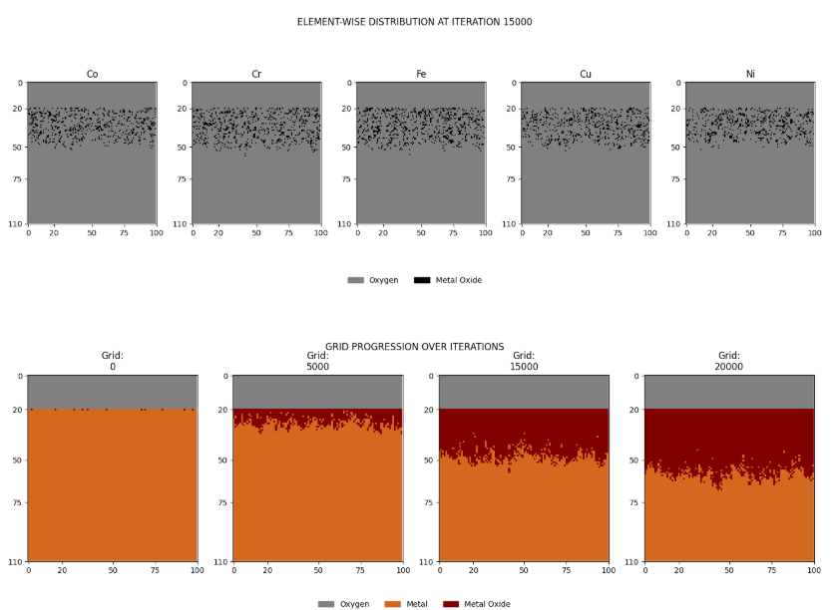

Figure 5.2) Grid progression for CoCrFeCuNi alloy system at 900 Celsius



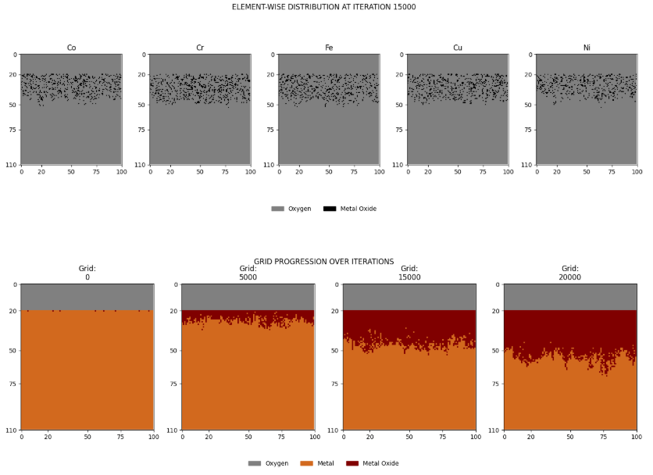

Figure 5.3) Grid progression for CoCrFeCuNi alloy system at 800 Celsius

The following graphs present in Figure 5.4 plot how the composition of metals in the alloy change with the temperatures between iteration 1000 to 20000. Each plot/graph represents the composition vs iteration for each element in the grid system. The subplots in the plot compare the variations with respect to temperature. Further we noticed that in many cases the element wise composition steadily increases between iterations and overall, it increases with the temperature used. There have been some elements in some alloys where the composition in between the progression of the simulation seems to have kinks and fluctuating behaviour. But the overall final composition of the elements after all 50,000 iterations have been run are stable and seem well separated with noticeable differences. In both the alloy systems the overall oxide composition increases with increasing temperature. The final oxide compositions results are represented below in Table 5.1)

|  |  |  |  |  |  |  |
| --- | --- | --- | --- | --- | --- | --- |
| Temperature (°C) | Co (%) | Cr (%) | Fe (%) | Cu (%) | Ni (%) | Total (%) |
| 600 | 8.00 | 9.00 | 8.62 | 8.45 | 7.88 | 41.95 |
| 700 | 9.66 | 9.97 | 10.02 | 9.66 | 8.95 | 48.26 |
| 800 | 9.99 | 10.85 | 10.19 | 10.35 | 9.56 | 50.94 |
| 900 | 10.35 | 11.17 | 11.21 | 10.57 | 10.38 | 53.68 |
| 1000 | 12.66 | 13.57 | 13.59 | 13.25 | 12.43 | 65.49 |

Table 5.1) Element-wise Temperature vs composition variation for elements of CoCrFeCuNi alloy system

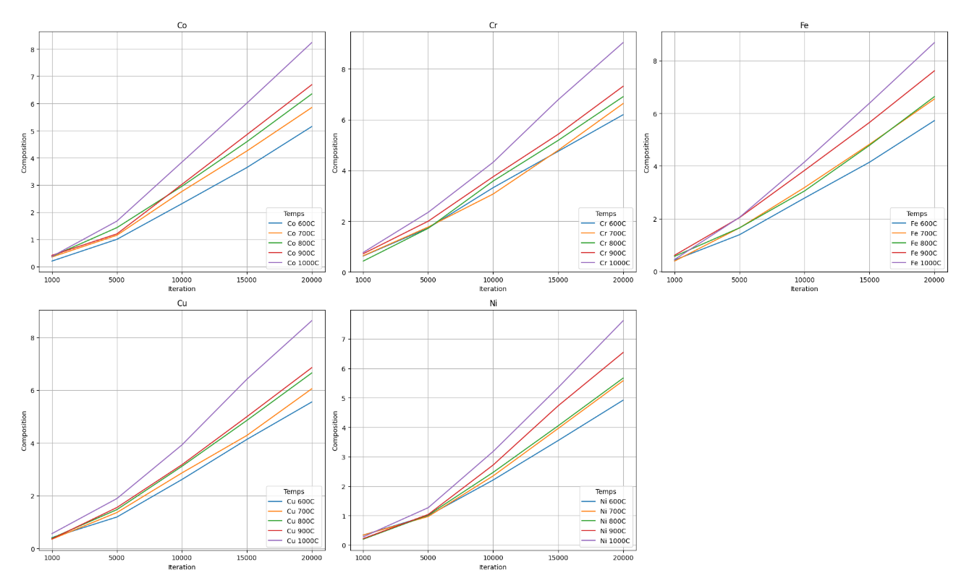

Figure 5.4) Element-wise comparison of composition growth over iterations between and inclusive of 600-1000 Celsius for elements present in CoCrFeCuNi alloy system

In Figure 5.5) the plots represent the final element composition after all iterations have been completed. This represents the final state of the alloy after the simulation is completed. This represents after sufficient oxidation has been completed and majority rows of the grid have been affected. X-axis represents the elements and Y-axis represents the Composition %. Again, subplots to compare the temperatures between 600-1000 Celsius are plotted and from this graph we can conclude the overall oxide composition in the entire metal system post complete oxidation, reduction and exchange reactions.

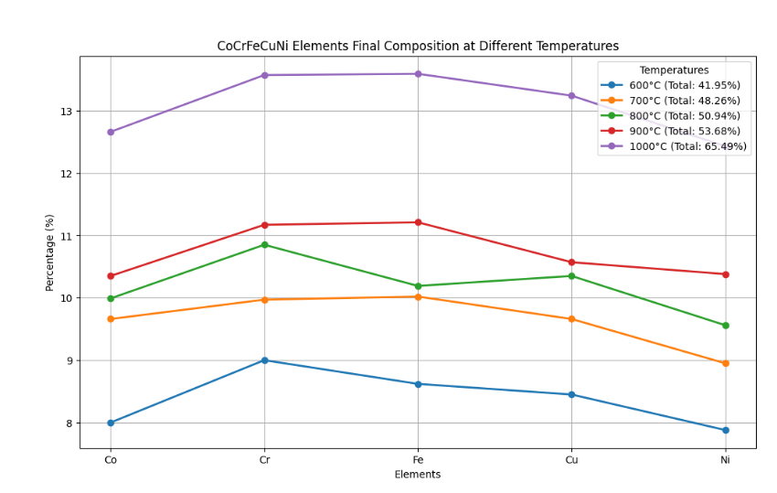

Figure 5.5) Final composition of elements present in CoCrFeCuNi between 600-1000 Celsius

We used PBR (Pilling Bedworth Ratio) to analyse the optimal area of safe oxides.

PBR = Cr: 2.07, Fe: 1.90, Cu: 1.68, Ni: 1.65, Co: 1.89, Mn: 1.74

We used the following formula to estimate the safe and unsafe region of overall composition present in the alloy system.

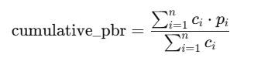

Here N denotes the number of elements and this formula is a weighted summation by taking element wise composition multiplied by it’s PBR ratio divided by the overall composition summations.

When the value “cumulative PBR” falls between and inclusive of 1.0 and 2.0, the oxide composition and distribution is said to be “safe”. Table 5.3) and 5.4) represent the iterations around which the cumulative PBR values were present between 1.0 and 2.0 for each alloy system which correspond to safe oxide layer

|  |  |  |
| --- | --- | --- |
| Temperature | SAFE OXIDE  START ITERATION NUMBER | UNSAFE OXIDE  START ITERATION NUMBER |
| 600 | 3500 | 7100 |
| 700 | 3500 | 7100 |
| 800 | 2600 | 5800 |
| 900 | 3200 | 6200 |
| 1000 | 2700 | 5500 |

Table 5.3) PBR values for CoCrFeCuNi between 600-1000 Celsius

1. Use-cases in real world applications

This experiment creates a unified solution to perform stochastic simulations on any metal alloy system. This would mean that metallurgists and material scientists can use these models to analyse alloy behaviour at any temperature. The resulting data can be used for spatio-temporal analysis to find trends in how specific oxides progress through an alloy system. We can study the affinity and occurrences of reaction reactions and exchange reactions that occur in a grid. Even in naive chemistry, we can only keep track of reduction, oxidation and any reverse reactions, but with the success of our simulation arrangement to mimic real world results, we can understand, the time-temperature dependence on how trigger oxidation and reduction reactions. Boundary conditions are incorporated which gives us insights on how oxide layers progress throughout the bulk of a material and studying them in laboratories or via hands-on experiments requires extensive set-up and significant computational power. This removes all such barriers with very simple yet powerful setup

While real-world experiments take up from multiple days to weeks for studying behaviours of alloys of such types with a lot of manual intervention, our algorithm is designed to optimally work on simple CPUs without any computational requirements. For example: Running 50,000 iterations on a 100x100 grid would take 25 minutes at max. But here each iteration does not have any specific correlation with time.

A basic thumb rule is that every 5000 iteration denote 6 hours.

Assigning arbitrary values to each grid size as heigh x width would be analogical to studying simulation behaviour in inorganic thin film materials Doing so would help be helpful to calculate weight loss in the alloy or the system chosen for simulation by simply following the

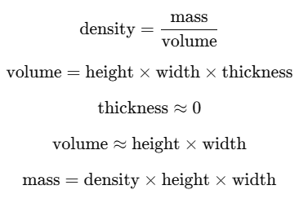

1. Conclusion

This project introduces a new stochastic cellular automata model to simulate the high-temperature oxidation behaviour of high entropy alloys (HEAs) CoCrFeCuNi and CoCrFeMnNi. With the incorporation of oxide-specific diffusion coefficients, temperature-dependent activation energies, and competitive oxidation-reduction dynamics, the model presents a more realistic simulation of oxidation in multi-component systems. Simulations retain clear temperature-dependent trends in oxidation, with oxide contents varying between 46.65% and 62.52% for CoCrFeMnNi and 41.95% and 65.49% for CoCrFeCuNi as temperature goes from 600°C to 1000°C—trends consistent with experimental results. Pilling-Bedworth Ratio analysis also detects significant oxidation transition points, with initial safe oxide formation at higher temperatures. The model is computationally effective, taking 50,000 iterations ~ 25 minutes on a standard CPU, and provides spatiotemporal information which is not attainable much easily experimentally. Although the current project is focused on 2D thin films and it still offers valuable guidance for oxidation-resistant alloy design and the dataset generated can be used to develop tailored deep machine learning models like ResNet, Volumetric Neural Networks (V-Nets, U-Nets) to analyse 3d information from 2d data. Future work might build upon this and extend to 3D systems, add microstructural information, and better match parameters with experimental data for increased accuracy. Generally, this model offers a transferable framework for the creation of computational alloy design and high-temperature material development. As we can access the safe vs unsafe oxidation phase, making these models more accurate would greatly benefit in analysing corrosion behaviours and developing protective systems to automate coatings or sending alerts to premature corrosion identification. Assigning appropriate dimensions (height, width, thickness) by rigorous testing and generating deterministic models can yield results on how material surface decays and trends or patterns can be noted down. From existing research going on in cellular automata, generally a single grid cell is considered to be 0.1 x 0.1 micron in size. Extending research in determining the exact value would be even more useful to extract full information out the simulation. In such cases, we can assign a grid to be hold more than 1 metal to make the reaction progression even more granular. There have been no developments on correlating the grid structures with grains, grain boundaries and microstructures. Using larger grids or even using Moore Neighbourhood criteria (which uses 8 neighbours instead of 4 in Von Neuman) might contribute to any findings in these areas.

1. References
2. S.Paswan, R.Mitra and S.K. Roy “Oxidation behaviour of the Mo-Si-B and Mo-Si-B-Al alloys in the temperature range of 700-1300°C” Intermetallics 15,pp 1217-1227,2007.
3. R.Mitra, A.K.Srivastava,N.Eswara Prasad and Sweety Kumari, Intermetallics 14, pp1461-1471,2006.
4. Yeh, J.W., et al., Nanostructured high-entropy alloys with multiple principal elements: Novel alloy design concepts and outcomes. Advanced Engineering Materials, 2004. 6(5): p. 299-303. 8.
5. Cantor, B., et al., Microstructural development in equiatomic multicomponent alloys. Materials Science and Engineering A, 2004. 375-377: p. 213-218.
6. Gali, A. and E.P. George, Tensile properties of high- and medium-entropy alloys. Intermetallics, 2013. 39(0): p. 74-78.
7. Liu, W.H., et al., Grain growth and the Hall-Petch relationship in a high-entropy FeCrNiCoMn alloy. Scripta Materialia, 2013. 68(7): p. 526-529.
8. Senkov, O.N., et al., Microstructure and room temperature properties of a high-entropy TaNbHfZrTi alloy. Journal of Alloys and Compounds, 2011. **509**(20): p. 6043-6048.
9. Zhang , Y., et al., Minor a!!oying behavior in bulk metallic glasses and high-entropy alloys.Science in China Series G-Physics Mechanics & Astronomy, 2008. 51(4): p. 427-437.
10. Zhang, Y., et al., Solid-solution phase forlllation rules for lllU!ti-co111po nent a!!oys.Advanced Engineering Materials, 2008. 10(6): p. 534-538.
11. Zhang, Y., X. Yang, and P.K. Liaw, Alloy design and properties optill=li ation of high­ entropy a!!oys. JOM , 2012. 64(7): p. 830-838.
12. Z.Tang, Andrew J. Thom, M.J. Kramer and Mufit Akinc, Intermetallics 16, pp1125-1133, 2008.
13. S. Franz, H. Saage,M.Kruger, M. Heilmaier and J.H. Schneibel, Intermetallics 16,pp 33-941, 2008.
14. T. Hayashi, K. Ito, K. Ihara, M. Fujikura and M. Yamaguchi, Intermetallics 12, pp 699-704, 2004.
15. V. Supatarawanich, D. R. Johnson and C. T. Liu, Intermetallics 12, pp 721-725,2004.
16. Senkov, O.N., et al., Low-density, refracto,y multi-principalelement alloys of the Cr-Nb­ Ti-V-Zr system:Microstructure and phase analysis. Acta Materialia, 2013. 61(5): p. 1545- 1557.
17. Senkov, O.N., et al., Refractory high-entropy alloys. ln tenn etallics , 2010. 18(9): p. 1758- 1765.
18. Yeh, J.W., Alloy Design Strategies and Future Trends in High-Entropy Alloys. Jom, 2013. 65(12): p. 1759-1771. 30.
19. Guo, S., et al., More than entropy in high-entropy alloys: Forming solid solutions or amorphous phase. Intermetallics, 2013. 41: p. 96-103.
20. Buckman Jr, R., Alloying of refractory metals. ASM International, Alloying, 1988: p. 419-445.
21. S. Ranganathan, Alloyed pleasures: multimetallic cocktails, Curr Sci India 85(10) (2003) 1404- 1406.
22. Miracle, D. and O. Senkov (2017). "A critical review of high entropy alloys and related concepts." Acta Materialia 122: 448 - 511.
23. B.S. Murty, J.-W. Yeh, S. Ranganathan, P. Bhattacharjee, High-entropy alloys, Elsevier 2019.
24. Guo, S., et al., More than entropy in high-entropy a!!oys: Forming solid solutions or amorphous phase. Intermetallics , 2013. 41: p. 96-103 .
25. Guo , N .N., et al., Microstructure and mechanical properties of refractory MoNbHJZrTi high-entropy alloy. Materials & Design, 2015. 81: p. 87-94.
26. Morinaga , M., et al., Solid solubilities in transition-llleta l-ba sed fee alloys. Philosop hical Magazine A, 1985. 51(2): p. 223 -246.
27. Wang, X.F., et al., Novel 111icrostructureand properties of multicomponent CoCrCuFeNiTix alloys. lntenn etallic s, 2007. 15(3): p. 357-362.
28. Yeh, J.W., et al., High-entropy alloys - A new era of exploitation. Mate rials Science Fornm,2007. 560: p. 1-9.
29. Bronislava Gorr, Steven Schellert, Franz Müller, Hans-Jürgen Christ,Alexander Kauffmann, and Martin Heilmaie, “Current Status of Research on the Oxidation Behavior ofRefractory High Entropy Alloys”, Adv. Eng. Mater.2021,23.
30. [Karthikeyan Hariharan](https://arxiv.org/search/cond-mat?searchtype=author&query=Hariharan,+K), [K. Sivaprasad](https://arxiv.org/search/cond-mat?searchtype=author&query=Sivaprasad,+K), “Sustainable low-cost method for production of High entropy alloys from alloy scraps”, April 2022, [Journal of Sustainable Metallurgy](https://www.researchgate.net/journal/Journal-of-Sustainable-Metallurgy-2199-3823) 8(3).
31. I.S. Wani, T. Bhattacharjee, S. Sheikh, Y.P. Lu, S. Chatterjee, P.P. Bhattacharjee, S. Guo, N. Tsuji, Ultrafine-Grained AlCoCrFeNi2.1Eutectic High-Entropy Alloy, Materials Research Letters 4(3) (2016) 174-179.
32. Tsai, K.Y., M.H. Tsai, and J.W. Yeh, Sluggish diffusion in Co-Cr-Fe-Mn-Ni high-entropy alloys. Acta Materialia, 2013. 61(13): p. 4887-4897.
33. Wu, W.H., C.C. Yang, and J.W. Yeh, Industrial development of high-entropy alloys. Annales De Chimie-Science Des Materiaux, 2006. 31(6): p. 737-747.
34. [Christiane Stephan-Scherb](https://link.springer.com/article/10.1007/s11085-020-10014-7#auth-Christiane-Stephan_Scherb),  [Wencke Schulz](https://link.springer.com/article/10.1007/s11085-020-10014-7#auth-Wencke-Schulz),  [Mike Schneider](https://link.springer.com/article/10.1007/s11085-020-10014-7#auth-Mike-Schneider),  [Stephanos Karafiludis](https://link.springer.com/article/10.1007/s11085-020-10014-7#auth-Stephanos-Karafiludis) and [Guillaume Laplanche](https://link.springer.com/article/10.1007/s11085-020-10014-7#auth-Guillaume-Laplanche), “High-Temperature Oxidation in Dry and Humid Atmospheres of the Equiatomic CrMnFeCoNi and CrCoNi High- and Medium-Entropy Alloys”, [Oxidation of Metals](https://link.springer.com/journal/11085) volume 95, pages105–133 (2021).
35. [Lin Wang](https://pubmed.ncbi.nlm.nih.gov/?term=Wang%20L%5bAuthor%5d), [Quanqing Zeng](https://pubmed.ncbi.nlm.nih.gov/?term=Zeng Q[Author]), [Zhibao Xie](https://pubmed.ncbi.nlm.nih.gov/?term=Xie Z[Author]), [Yun Zhang](https://pubmed.ncbi.nlm.nih.gov/?term=Zhang%20Y%5bAuthor%5d) and [Haitao Gao](https://pubmed.ncbi.nlm.nih.gov/?term=Gao%20H%5bAuthor%5d), “High Temperature Oxidation Behavior of an Equimolar Cr-Mn-Fe-Co High-Entropy Alloy”, [Materials (Basel).](https://www.ncbi.nlm.nih.gov/pmc/articles/PMC8346963/) 2021 Aug; 14(15): 4259.
36. B. Ren, Z.X. Liu ∗ , D.M. Li, L. Shi, B. Cai, M.X. Wang, “Effect of elemental interaction on microstructure of CuCrFeNiMn high entropy alloy system” Journal of Alloys and Compounds 493 (2010) 148–153.
37. A. Kumar, P. Dhekne, A. Kumar, M. Kumar, “Analysis of Si addition on phase formation in AlCoCrCuFeNiSix high entropy alloys," Mater. Lett., vol. 188, pp. 73-76, 2017.
38. H.X. Sui, M. Zhu, M. Qi, G.B. Li, D.Z. Yang, "The enhancement of solid solubility limits of AlCo intermetallic compound by high-energy ball grinding," J. Appl. Phys., vol. 71, pp. 2945–2949, 1992.
39. Z. Fu, W. Chen, H. Xiao, L. Zhou, D. Zhu, S. Yang, "Fabrication and properties of nanocrystalline Co0.5FeNiCrTi0.5 high entropy alloy by MA-SPS technique," Mater. Des., vol. 44, pp. 535–539, 2013.
40. A. Kumar, A.K. Swarnakar, M. Chopkar, "Phase Evolution and Mechanical Properties of AlCoCrFeNiSi x High-Entropy Alloys Synthesized by Mechanical Alloying and Spark Plasma Sintering," J. Mater. Eng. Perform, vol. 27, pp. 3304–3314, 2018.
41. Indranil Roy, Pratik K. Ray, Ganesh Balasubramanian “Modeling Oxidation of AlCoCrFeNi High-Entropy Alloy Using Stochastic Cellular Automata “